KAS NEWS
JUNE 2021.

Dear KAS members:
As the year advances and our Annual Exhibition approaches, we seem to be increasingly busy, with more events and tasks to organise. There is a lot to cover in this newsletter!

Favourable comments have been received about our revamped website. Check it out if you haven't. Thanks to Anthony at Handmade Web, Berry.

ANNUAL EXHIBITION
An exhibition only works if artists enter - so please do your bit to make our 43rd a huge success!
Entry Form can be downloaded from the website www.kiamaartsociety.org.au.
Paper copies of the Entry Form and Conditions are now available from the Visitors Centre, Framed By Us, Levers Wollongong, ArtHouse Direct Nowra, Terra Gallery Kiama, Fern Street Gallery Gerringong, and also at Alexander Art Supplies at the Collective.

KEY DATES: Entries close July 28th. Delivery of paintings Wed August 25. Preview night Friday August 27. Awards Ceremony August 28 at 4 pm. Collection of paintings September 4 from 3pm.
NOTE: To assist the treasurer, payment is to be made and notified to the treasurer when the entry form is submitted.

VOLUNTEERS: We will need volunteers for bump in and set up, registration (desk sitters and runners), hanging roster, and exhibition sitting roster.
Check your diaries now and email availability to Robyn.

NEXT OLD FIRE STATION: July 29 to August 11. This 2 week period will give us a great opportunity to publicise our Annual Exhibition. Details re how the 2 weeks will be organised will be distributed ASAP, but mark these dates in your diary. Email contact for the OFS is Micheleskusa@gmail.com

DEMONSTRATIONS:
JUNE: Congratulations to Salwa Woodroffe for an excellent demonstration of a landscape using oils and a palette knife. A beautiful result accomplished in a very short time. Thanks Salwa.

NEXT - JULY 6TH. Sydney artist Joe Bezzina - an acrylic seascape with rock platform, reflecting the landscape of our local area. Members: $15 including delicious afternoon tea.
PAYMENT: Eftpos when booking with Robyn, or at the door, or cash. (Please have correct money)

FUTURE DEMONSTRATIONS:
If anyone would consider doing a demonstration for KAS, or can suggest a local or Illawarra artist who might be interested, please email Robyn your suggestion.

WEEKLY ART GROUP - WAGS
Each THURSDAY at the COACHHOUSE. Come along and share a fun sociable time painting with KAS friends. 10am to about 2.30pm. $5 each, which includes a cuppa. BYO lunch and equipment. CALL CAROLE ON 0419 410 280.

CLASSES - COMING SOON
MIXED MEDIA CLASSES WITH KAREN WRIGHT. Karen will introduce multiple techniques for use in mixed media works. Venue: The Coach house. Dates: 4 parts - Monday !9th July, Monday July 26th, Monday August 2nd and Monday August 16th. Time: 10am to 12.30pm (NOTE: not 2.30 as previously advertised.) Cost is $200, which includes all mixed media materials.
Some spots still available. To book email Karen on karenannewright@outlook.com

ANNUAL MEMBERSHIP FEE OF $40 was due on 31ST MARCH.
Unfinancial members who have not rejoined KAS have now been removed from our data base and will not receive newsletters or member benefits. To rejoin now, you must complete a new membership application form, giving all details. Membership forms are available at demos and on our website, or email kas.robyn@gmail.com
Payment: Preferred payment is Direct Deposit : Westpac BSB 032 689: Account Number 540 168, or you can pay in person at a demonstration with Cash (correct money in an envelope with your application form), or cheque (please write KAS fees and your name on the reverse of the cheque), or by eftpos,

MEMBERSHIP CARDS: if you are financial and have not received a receipt with a photocopied membership card attached, please email Robyn and one will be emailed back.
ALTERNATELY
If you would like a "card" version you can ask for one at any event, or send a self-addressed envelope to KAS P/O. BOX 707, Kiama 2533, and one will be posted.
Carry your card or receipt, as proof of KAS membership if you wish to receive the members' discount from Alexander Art Supplies or from our art supply sponsors Levers Wollongong and ArtHouse Direct, Nowra

A NEW KAS OPPORTUNITY:
Expressions of Interest are being sought from members for a "KAS Members' Open Studio Trail." If you want to know more, please check this in the "FORMS" section of our website, where the proposal is outlined. Please complete the EOI form and return to Robyn by July 10th.

MEMBERS NEWS: Coming Exhibitions by members can be advertised on Facebook by sending details and pictures to Karen Wright at karenannewright@outlook.com.
Send all details to Robyn McMillan for inclusion in our newsletter.

EXHIBITIONS BY MEMBERS:
- Heidi Uhlig and Michelle Skuza are currently exhibiting at Terra Gallery. Tuesday - Sunday 10am till 4pm
- Kathy Karas and Carole Massey have continuing exhibitions at Terra Gallery. Tuesday - Sunday, 10am till 4 pm.
- Salwa Woodroffe will have a solo exhibition at Terra Gallery - 3rd to 18 July.
- Helen Pain has a solo exhibition at The Yallah Woolshed Artspace. Now till June 30th. Open each day till 2.30pm.
- Member Wendy Dobson is exhibiting at The Art Bar, Kiama through June.

43RD KAS ANNUAL EXHIBITION SPONSORS

We are delighted to welcome back many loyal sponsors, and also to welcome new sponsors to our Exhibition.

Thank you to the following Businesses and Organisations:

Kiama Municipal Council - Kiama Leagues Club - Illawarra Financial Group
Furniture One Kiama - Burnetts On Barney - Kiama and District Business Chamber
Raine and Horne Kiama - Terra Gallery, Kiama - Bombo Curtains and Blinds
Easts Beach Big 4 - Framed By Us - Health Destination Pharmacy Kiama
Fern Street Gallery Gerringong - Kerry's Klothes, Kiama - The Art Bar, Kiama
Kiama Smile Elite Real Estate - Greg Rodgers and Associates
Kiama Refrigeration and Airconditioning
Levers Art Supplies,Wollongong - Arthouse Direct, Nowra

Please support these local businesses who are generously supporting us
this year.

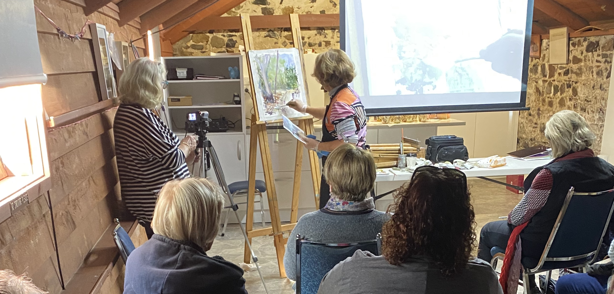

A full house at the Coach House enjoying Salwa Woodroffe's June demonstration

Happy painting everyone
Helen and Robyn

